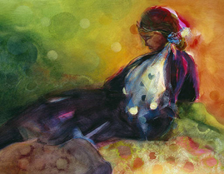

You can pretend it's not there.

You can ignore it when it speaks to you.

You can build a wall to hide it from yourself.

**But it's still there.**

**You were born with the knowledge that you are living your life**

**under the eye of One who knows you...**

…. and to whom you will account for what you did with the light you had.

Everything depends on what you do with this knowledge.

***And this is the judgment, that the light has come into the world, and men loved darkness rather than light, because their deeds were evil. For every on who does evil hates the light, and does not come to the light, lest his deeds should be exposed. But he who does what is true comes to the light, that it may be clearly seen that his deeds have been wrought in God.***

*John 3:19-21*

As the light of God begins to search us, our innate knowledge of God develops into one of two things:

**faith.**

**unbelief.**

Unbelief is not lack of faith, it is rebellion.

It is rejecting spiritual light and embracing spiritual darkness with an act of will.

To have faith is to embrace the light which is most clearly seen in the person of the crucified and risen Lamb of God.

**Look to him, and open your heart, and faith becomes possible.**

***"Behold the Lamb of God who takes away the sin of the world!"***

***"I am the light of the world; he who follows me will not walk in darkness but will have the light of life."***

*John 8:12*

*Richard Bieber: 2004*

*Art: Jen Norton*

[**Maranatha Mirror Messages**](http://mmirror.net/more-messages/)

](http://mmirror.net/about/)[mmirror.net](http://mmirror.net/)