

Come to me all you who labor and are heavy-laden and I will give you rest.

"Lord, I did that, and nothing happened.

I'm still as burdened down and weary as ever."

"You came to me? How did you come to me?"

"I answered an altar call. I came forward and prayed the sinner’s prayer.
For a few days I had great peace. Then it all evaporated."

"But did you get under my yoke?"

"Your yoke?"

"You really haven't come to me, until you're under the yoke with me.

Until you're walking with me, obeying me, learning from me."

"But I thought salvation was free. Now you tell me I have to do something!"

"Salvation is free, but you won't find it anywhere but under my yoke.

So join me under this yoke of servanthood.

You will learn from me to be meek and lowly of heart.

You will experience unspeakable peace as we serve together

Come!"

"I have been crucified with Christ.
It is no longer I who live, but Christ who lives in me. And the life I now live in the flesh I live by the faith of the Son of God who loved me and gave himself for me."
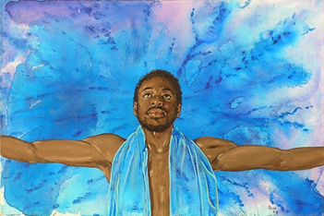
Galatians 2:20

Dead and Alive with Christ Fr. James Hasse
Message: Richard E. Bieber 2003

Maranatha Mirror Messages

mmirror.net

