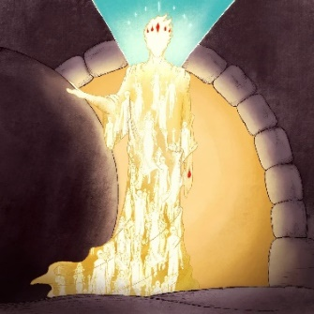

**Yes, he really did rise from the dead.**

Not as a myth.

Not as a ghost.

But as the Firstborn of a New Creation.

But you will never believe it until he raises you from the dead---

**---now, here in this life.**

***"The hour is coming and now is, when the dead shall hear the voice of the Son of God. And those who hear shall live."***

*John 5*

He will raise you from the dead, now in this life, when you hear his voice----and pay attention.

It may not be audible.

It may come as a Word so ordinary and straightforward, that you will be tempted to ignore it.

But if you wake up and realize that this Word is addressed to you, you will truly rise out of your spiritual grave, and begin to live.

***"The hour is coming and now is, when the dead shall hear the voice of the Son of God. And those who hear shall live."***

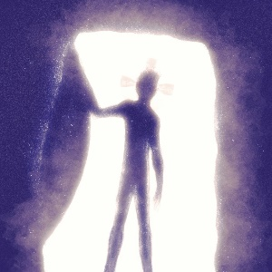

*Messages: Richard Bieber 2016*

](http://mmirror.net/about/)*Art: Chris Powers at Full of Eyes*

[**Maranatha Mirror Messages**](http://mmirror.net/more-messages/)

[mmirror.net](http://mmirror.net/)