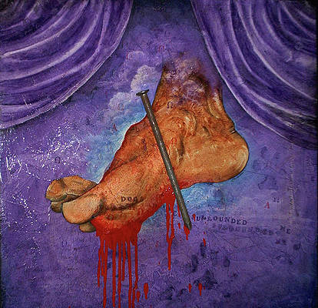

But he was wounded for our transgressions,
He was bruised for our iniquities;
Upon him was the chastisement that made us whole,
And with his stripes we are healed. (Isaiah 53)

Never mind trying to figure out how it works. You never will. But it works.

Find this Wounded Healer, and you find life.

Start with whatever it is that weighs you down.

The problem that won't go away.
The pain (mental or physical) which drains your strength.
The anxiety which haunts your days.

"Lord, wherever you are, help me!"
"I don't deserve it. My faith is weak.
I confess my need of forgiveness.
So I throw myself on your mercy."

"All that the Father gives me will come to me;
and him/her who comes to me I will not cast out."

Cry out to him, and he will come to you.
Call on his name and he will visit you with healing.

"Jesus, Master! Have mercy on me!"

"But why should I call on him now, when I'm in trouble? When things were going well I never thought about him."

"Those who are well have no need of a physician, but those who are sick. Go and learn what this means, 'I desire mercy, and not sacrifice.' For I came not to call the righteous, but sinners."

Matthew 9:12-13

Message: Richard E. Bieber 2017
Artwork: Christopher Marion Thomas

Maranatha Mirror Messages
mmirror.net


