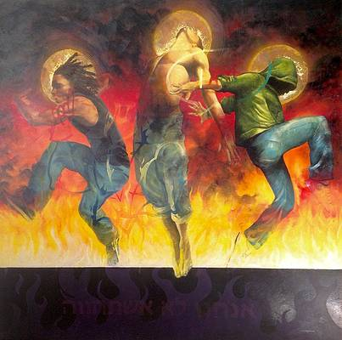

"Faith" from the human point of view: A man or woman with a somber face, jaw set, fists clenched, battling their way through the storms of life "by faith."

Faith as Jesus reveals it: Not only are you in touch with reality….

**You're having fun.**

**Even when things are difficult, you're still having a good time within,**

….*as you walk in God's light.*

The thing that bugged the Pharisees about Jesus' disciples was that they were out there in the real world having a good time. *"How can they be men of faith, if they're having fun?"*

**You only start having any fun in life when you discover**

**you have a Heavenly Father whom you can absolutely trust.**

He doesn't need the help of your worry to run his universe.

He knows what he's doing.

He knows you and loves you with unspeakable love.

He sent his Son to open for you a destiny far more wonderful than your mind could grasp....and his Spirit to guide you there.

Once you begin to see this and understand it, all you have to do is put your life at his disposal by faith.

**Let his Word be your doorway to a new life, as you act on it with joyful trust.**

***Because the Lord is my Shepherd, I have everything I need! He lets me rest in the meadow grass and leads me beside the quiet streams. He gives me new strength. He helps me do what honors him the most.Even when walking through the dark valley of death I will not be afraid, for you are close beside me, guarding, guiding all the way. You provide delicious food for me in the presence of my enemies. You have welcomed me as your guest; blessings overflow! Your goodness and unfailing kindness shall be with me all of my life, and afterwards I will live with you forever in your home.*** *Psalm 23 (TLB)*

*Richard Bieber*

*Art: Christopher Marion Thomas*

[**Maranatha Mirror Messages**](http://mmirror.net/more-messages/)

[mmirror.net](http://mmirror.net/)

](http://mmirror.net/about/)