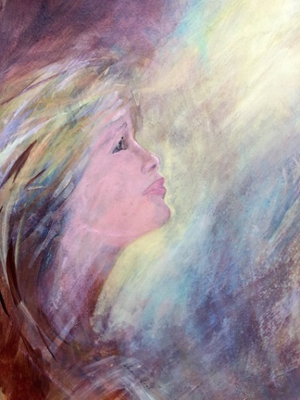
Out of the blue..

A voice.
Am I hallucinating?
Losing my mind?

A distinct awareness that I'm being called….

….to change direction.
….to repent.
….to turn from Darkness to Light.

But even before I was born, God chose me and called me by his marvelous grace.
Galatians 1:15

The Transcendent,
Unknowable God is also Immanent.

If it hasn't happened to you yet… it will.

You will encounter his voice…his call.

“Truly, truly, I say to you, an hour is coming, and is now here, when the dead will hear the voice of the Son of God, and those who hear will live.
John 5:25

Once you hear the call, it’s a matter of answering it…

Day by day.
Hour by hour.

Those who hear shall live.
Richard Bieber
Art: Sara Joseph

Maranatha Mirror Messages
mmirror.net


