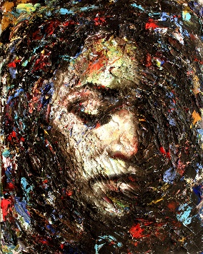

*"Look, I'm a very spiritual person.*

So don't talk to me about God.

And, for goodness sake, leave Jesus out of it!"

Why can't we talk together about God?

Why does this name, "Jesus" make you uncomfortable?

**What are you afraid of?**

I'm not asking you to become religious.

I'm not begging you to come to church.

Nor can I defend the horrors that have been foisted on mankind "in the name of Jesus."

I'm inviting you to listen to his simple "unreligious" message.

Those few words which have survived twenty centuries, and still speak peace to the humble heart.

**Just listen until his words penetrate your soul.**

**He doesn't need me to convince you.**

**He will do his own convincing.**

***Pilate said to him, "So you are a king?" Jesus answered, "You say that I am a king.***

***For this I was born, and for this I have come into the world, to bear witness to the truth.***

***Everyone who is of the truth hears my voice." Pilate said to him,***

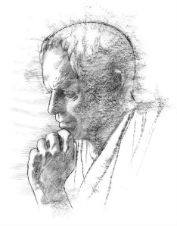

***"What is truth?"***

Some get it. Some don't.

**But it's worth checking out---first-hand.**

*Richard Bieber*

*Art: Chris Hopkins*

[**Maranatha Mirror Messages**](http://mmirror.net/more-messages/)

[mmirror.net](http://mmirror.net/)

](http://mmirror.net/about/)