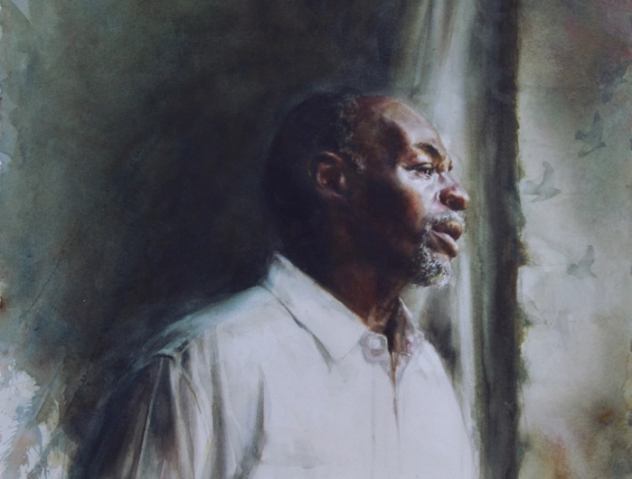

They that wait on the Lord
shall renew their strength.
Isaiah 40:31

So how do you “wait on the Lord?”
You pray?
You meditate?
You open your soul to his light?
For sure.
But there is an aspect to “waiting on the Lord” that often frustrates us:

Waiting.
Simply waiting.

Waiting for the Lord to come through with help.
Waiting for the Lord to answer the cry of our heart.

Waiting, while heaven is silent.
Waiting while the darkness continues.
And trusting that the Lord has not forsaken us.

Sometimes the answer to our prayer is instant.

Sometimes there is a long wait…..

….during which the Lord renews the strength of those who stay faithful.

Richard Bieber: 2018
Art: Suzy Schultz

Maranatha Mirror Messages
mmirror.net


