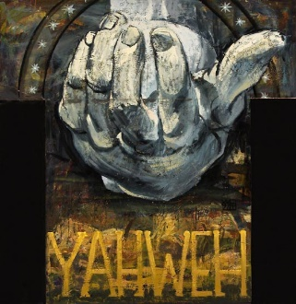
Looking for proof?
You will never find it.

Looking for God?
God will find you!
You will never know the living God until you wake up to the awesome fact……
…That God knows you!
Billions of souls on this planet, and God knows me?
That’s the mystery.
And the Voice your soul will hear…
Is the same Voice that echoed across Galilee:
The Voice of the Risen Lord Jesus.
“My sheep hear my voice, and I know them, and they follow me; and I give them eternal life. And they shall never perish, and no one shall snatch them out of my hand.” John 10
His word to you at this moment:
“Follow me.



Messages: Richard E. Bieber
Artwork: Wayne Forte
Maranatha Mirror Messages
mmirror.net


