TO BE KNOWN

Now I know in part; but then shall I know, even as also I am known.
I Corinthians 13:12

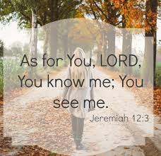

It comes as a flash of insight …

I am known by One who sees into my depths.

He knows me better than I know myself.

He sees me as I really am,
yet does not condemn.

What does he want with me?
Why is he looking into my soul?
Lord, you know everything there is to know about me. You perceive every movement of my heart and soul, and you understand my every thought before it even enters my mind.
Psalm 139:1-2
He waits for me to turn away from the darkness
---and face the light.

He waits for me to remove my mask---
---and confess my need.

He waits for me to abandon myself to his mercy
---in faith.

And Jesus cried out and said," He who believes in me believes not in me, but in him who sent me. And he who sees me sees him who sent me. I have come as light into the world, that whoever believes in me may not remain in darkness. John 12:44-46

Maranatha Mirror Messages
mmirror.net

maranathamirror18@gmail.com


