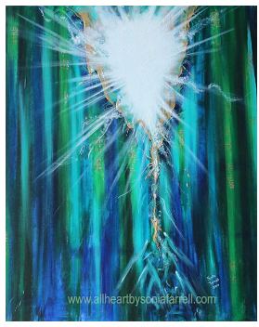

Our swelling ocean of information is still bordered by an Infinite Unknown.

All the smart phones, I-pads, and google searches cannot penetrate its mystery.

So why all the fever and sweat?

Better a handful of quietness
Than two hands full of toil and striving after wind.
Ecclesiastes 4:6

What is my life?

A striving after wind?
Or a pursuit of the one thing needful?

The One Thing needful:
To connect with the living God.
To pass from my darkness into his light.

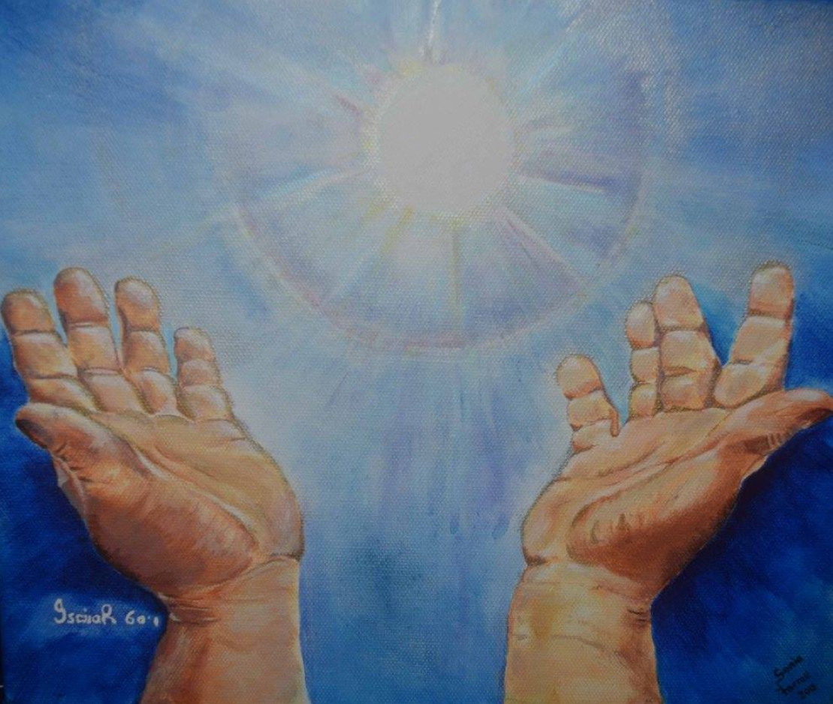

Messages: Richard E. Bieber
Art: Permission and courtesy of Sonia Farrell at allheartbysoniafarrell,com

Maranatha Mirror Messages
mmirror.net


