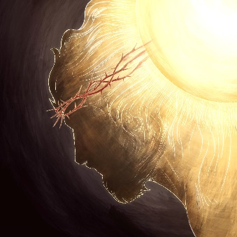

It’s invisible to the human eye.

But when it comes, our eyes see things they never saw before.

***The true light that enlightens every man was coming into the world. He was in the world, and the world was made through him, yet the world knew him not.***

***He came to his own home, and his own people received him not. But to all who received him, who believed in his name, he gave power to become children of God; who were born, not of blood nor of the will of the flesh nor of the will of man, but of God.*** *(John 1)*

Sooner or later the *“Light that enlightens everyone”* finds its way to every soul God ever made.

***“And I, when I am lifted up from the earth (on the cross) will draw all people to myself.”*** *John 12*

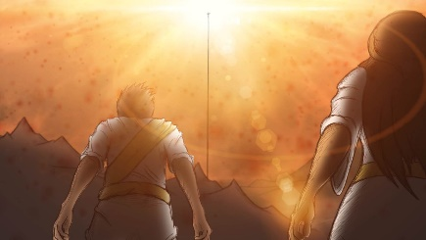

**When that Light reaches us, it’s a new dawn.**

**Our prison door flies open.**

All we have to do is follow the Light into the Kingdom for which we were made…

**….before the door closes.**

*Richard Bieber: 2019*

*Art: Chris Powers at Full of Eyes*

[**Maranatha Mirror Messages**](http://mmirror.net/more-messages/)

[mmirror.net](http://mmirror.net/)

](http://mmirror.net/about/)