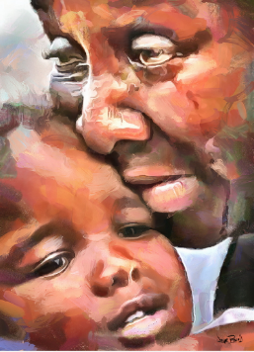

The injustice that wounds other lives may not move us.

But when we become the victim of a bureaucrat’s indifference, or a neighbor’s slander…

The sting of injustice flows into our soul with bewilderment and despair.

Where is God in all this?

Is there no justice?

There are two places where the God of the Universe exacts justice:

At Calvary

Where God himself absorbed all evil of all mankind into himself.

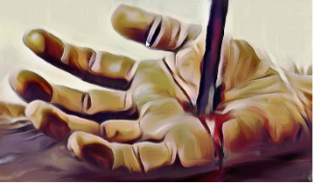

“Behold the Lamb of God who takes away the sin of the world.”

At the Last Day

When we will give account for what we did with the mercy shown to us.

When the Son of man comes in his glory, and all the angels with him, then he will sit on his glorious throne. Before him will be gathered all the nations, And he will separate them one from another as a shepherd separates the sheep from the goats. Matthew 25:31-32

Message: Richard E. Bieber
Artwork: Wayne Pascall

Maranatha Mirror Messages
mmirror.net


