THE STARTING POINT

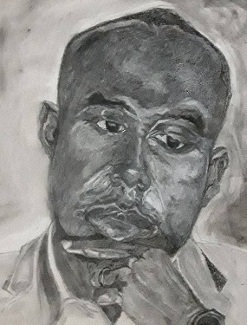

Long before you ever thought about God…

…..God was watching over you, as if you were his only child.

And yet, a living connection with God only takes place when your heart turns toward God.

Here's the starting point:

Ask, and it will be given you,
Seek and you will find,
Knock and it will be opened to you.

You may not see the Father's face.

You may have no conception of his love for you.

But the minute you begin to cry out to him in your need, all the riches of heaven are at your disposal.

For every one who asks receives,
And he who seeks finds,
And to him who knocks it will be opened.

You were created with the capacity to know God.

No matter how twisted and troubled your soul may be, that capacity is still there.

Your heavenly Father waits with open arms for you to take that first step.

Ask, and it will be given you!

Message: Richard E. Bieber 2015
Artwork: Godwin Amavi

Maranatha Mirror Messages
mmirror.net


