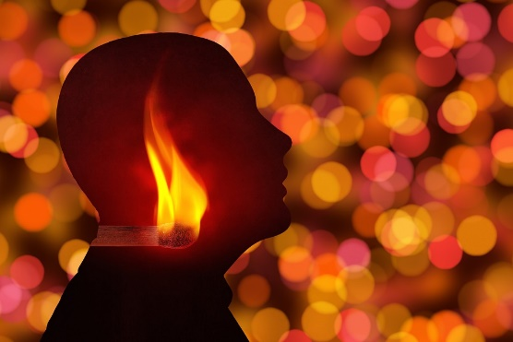

As surely as God is God,

Light from God was planted in you before you were born.

Like a compass pointing North, that Light points toward the Good…away from Evil.

The problem:

We all seem predisposed to ignore the Light…

…and choose our own way.

We stumble in the shadows.

The Light that enlightens every man was coming into the world. He was in the world, and the world was made through him, yet the world knew him not.

He came to his own home, and his own people received him not. But to all who received him, who believed on his name, he gave power to become sons and daughters of God, who were born, not of blood, nor of the will of the flesh, nor of the will of man, but of God. John 1

Before we can see the Light and walk in it;

The Incarnate Light on the outside…
needs to reignite the Light within.

He alone delivers us from the Darkness.

He opens our blind eyes.

He empowers us to walk as sons and daughters of God.

Richard Bieber
Art: Geralt on Pixabay

Maranatha Mirror Messages
mmirror.net


