**THE ENCOUNTER**

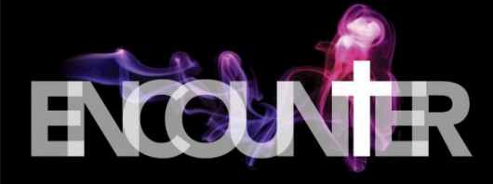

It always begins with an encounter.

Your eyes see nothing unusual.

Your ears hear no audible voice.

**Yet you're in the presence of the Living God.**

A word visits your consciousness

… that fills you with awe.

You are hearing the call to forsake the world of vanity

….and walk a new path.

***My sheep hear my voice***

***And I know them***

***And they follow me…***

**But what will you do with this encounter?**

You can brush it aside and go on with your life,

…With this difference:

Your innocence is gone.

You have been face-to-face with Truth.

Or you can answer the call,

pursue the Light,

following where the Shepherd leads.

***And I give them eternal life***

***And they shall never perish***

***And no one shall snatch them out of my hand.***

***John 10:27-28***

*Message: Richard E. Bieber 2012*

[**Maranatha Mirror Messages**](http://mmirror.net/more-messages/)

[mmirror.net](http://mmirror.net/)

](http://mmirror.net/about/)