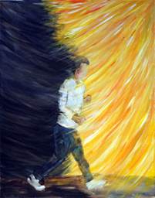

Your first encounter with God is almost always an "accident."

Something you stumble into.

The light comes on, and you hear a word.

It confounds your reason.

It baffles your mind.

It cuts at your heart like a knife.

**"Wake up!"**

"**What are you doing here?"**

**"Is this really what you want to do with your life?"**

**"Follow me."**

Your first inclination is to fight it.

"This can't be real!...What would God want with me?"

***“O Lord God,” I said, “I can’t do that! I’m far too young! I’m only a youth!” “Don’t say that,” he replied, “for you will go wherever I send you and speak whatever I tell you to. And don’t be afraid of the people, for I, the Lord, will be with you and see you through.”***

***Jeremiah 1:6-8*** *(NLT)*

Once you hear God's call, you can never erase it from your memory.

Sooner or later you will either answer with your life---

---or send it away forever.

***"*** ***So Jesus said to them, “The light is among you for a little while longer. Walk while you have the light, lest darkness overtake you. The one who walks in the darkness does not know where he is going.  While you have the light, believe in the light, that you may become sons of light.”.*** *(John 12:35-36)*

*Message: Richard E. Bieber 2015*

*Artwork: Eric Holmlund*

[**Maranatha Mirror Messages**](http://mmirror.net/more-messages/)

[mmirror.net](http://mmirror.net/)

](http://mmirror.net/about/)