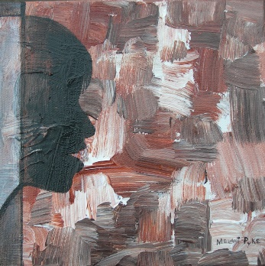

There are words that wake the dead,

words that comfort,
words that heal,
words that deceive,
words that discourage.
words that destroy.

Jesus says, “Whoever has ears to hear, let him hear.”

Because his words are Spirit and Life for those who have ears for them.

In a world where words are cheap and often misleading,

it is essential to discern the difference between words which come from the heart of God, and words which come from the father of Lies.

Why waste time listening to (or reading) words which are disposable,
why fill your mind with words which merely add to the clutter,
while Words from the heart of God are close at hand?

“Every one then who hears these words of mine and does them will be like a wise man who built his house upon the rock; and the rain fell, and the floods came, and the winds blew and beat upon that house, but it did not fall, because it had been founded on the rock.
“And every one who hears these words of mine and does not do them will be like a foolish man who built his house upon the sand; and the rain fell, and the floods came, and the winds blew and beat against that house, and it fell; and great was the fall of it.”
Matthew 7:24-27

Message: Richard E. Bieber 2004
Artwork: Melani Pyke

Maranatha Mirror Messages

mmirror.net

