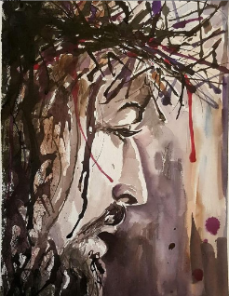
Once you know Jesus, you will discover that

behind all the suffering in this world,
behind all the things you yourself have suffered,
behind all the troubles you may now be facing,

… is a God who is holy, just, and righteous,

…he is also unspeakable Love.

Every sparrow that falls,
Every child that suffers,
Every pain any man or woman endures,

… is seen and remembered by a God who suffers with us,
… a God who has suffered for us in ways beyond our knowing.

He knows how to heal our broken hearts,
And he knows how and when to right all wrongs.

And he has provided a way out of this mess, into a world where all evil, all suffering, is absorbed into his own broken heart.

Some of us have been going to church all our lives.
We've known about Jesus since we were children.

Still, we have yet to come to know Jesus as the Way into God's World where we experience redemption.

Church doctrines have their place.
Creeds have their place.

But the essential thing is to know Jesus.

To know him.

Once you know Jesus---really know him---you have found redemption.

You have entered Life.

Now this is eternal life: that they know you, the only true God,
and Jesus Christ, whom you have sent (John 17:3)

Message: Richard E. Bieber 2003
Artwork: Cindy MacDonald

Maranatha Mirror Messages
mmirror.net


