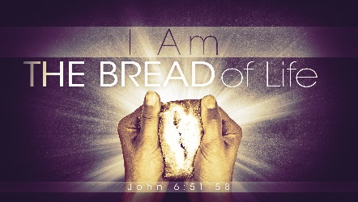

LIVING BREAD

"I am the living bread which came down from heaven; if any one eats of this bread, he will live forever." John 6:51

No matter who you are;
No matter how many failures lie behind you,
No matter how much guilt presses down on you…

If you eat this bread, you come to life.
God's Spirit enters you and raises you from the shadows into God's light.

Jesus, the Living Bread, offers himself to you in two miraculous ways:

1. He offers himself to you as the Lamb of God who takes all your guilt, all your wounds, all your regrets and failures upon himself.

“Come to me, give it all to me, and I'll give you rest from all that turmoil," he says.

2. He offers himself to you as the incarnate Word. He speaks words of life. All you have to do is open your heart and receive them.

"It is the Spirit that gives life," he says, "the flesh is of no avail; the words that I have spoken to you are Spirit and life."

The Living Bread is eaten by opening the heart to his Word.
Draw near and listen --- and live!

"As the living Father sent me, and I live because of the Father, so he who eats me will live because of me. This is the bread which came down from heaven, not such as the fathers ate and died; he who eats this bread will live forever." John 6:57-58

Message: Richard E. Bieber 2006

Maranatha Mirror Messages
mmirror.net
