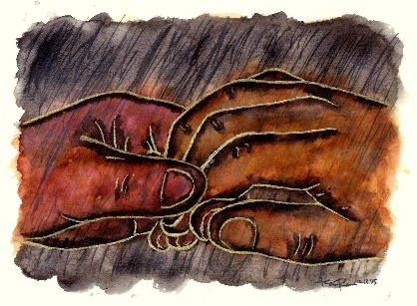

Sooner or later it will happen:

You will encounter the One who has known you since before you were born.
Knows you now.
Knows you better than you know yourself.

Faith is not a matter of believing certain doctrines.

Faith awakens when you encounter a Person…

…from "the other side of time."
…from "beyond the realm of death."

Who knows your name.
Who "understands your thought afar off."

Lord, you know everything there is to know about me.
You perceive every movement of my heart and soul,
and you understand my every thought before it even enters my mind.

If this has not happened to you yet, it will.

Faith in God cannot be self-generated.

It is awakened in you only by God himself.

The miracle usually occurs when, despairing of our illusions, and abandoning our vanity, we discover that we are known.

You are so intimately aware of me, Lord.
You read my heart like an open book and you know all the words I’m about to speak before I even start a sentence!
You know every step I will take before my journey even begins.
Psalm 139
Then you must decide daily: Will you walk toward the Light of the One who knows you, …or away from it?

Message: Richard E. Bieber 2012
Artwork: Ramone Romero

Maranatha Mirror Messages
mmirror.net


