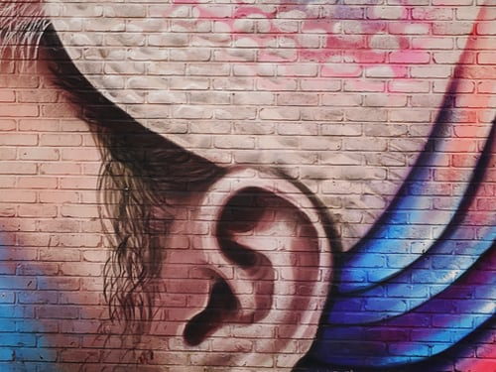

It came out of nowhere.

This sudden shock.

It has upset my whole life.

Will I ever be the same again?

One thing is certain:

This crisis has forced me to face issues I have avoided up to now.

And I'm beginning to wonder:

**Is God behind it?**

**Is he trying to tell me something?**

***Before I was humbled I used to always wander astray,  
but now I see the wisdom of your words. Everything you do is beautiful, flowing from your goodness; teach me the power of your wonderful words! Psalm 119:67-68 (TPT)***

Why is it that, for all the pain and disruption, my heart is beginning to find peace?

*Lord, give me ears to hear and eyes to see!*

*Lead me out of the shadows, into your light!*

*My past us is beyond my control.*

*My future is in your hands.*

*During this day, which you have given me,*

*Let me walk with you by faith.*

***But everyone my Father has given to me, they will come. And all who come to me, I will embrace and will never turn them away.***

***John 6:37 (TPT)***

*Message: Richard E. Bieber 2006*

[**Maranatha Mirror Messages**](http://mmirror.net/more-messages/)

](http://mmirror.net/about/)[mmirror.net](http://mmirror.net/)