I'M NOT RELIGIOUS, I'M SPIRITUAL!

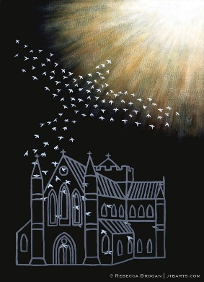

i.e. "I'm not into organized religion.
I have a spiritual routine that works for me."

But what if the God of the Universe is no more impressed with your "spiritual routine" than he is with "organized religion?"
What if your spiritual routine brings you no closer to the living God than the rituals of organized religion?

We come to life spiritually when we hear God speak…

…and receive from God the power to respond to what we hear.

Are you hearing the voice of God?

Is the life you live at this moment an answer to God's voice?

Pilate said to him, "So you are a king?"

Jesus answered, "You say that I am a king. For this I was born, and for this I have come into the world, to bear witness to the truth. Everyone who is of the truth hears my voice."
John 18

If you lay aside your vanity, and approach with integrity,

you will hear his voice.

And you will live
-----
spiritually.

Richard Bieber: 2019
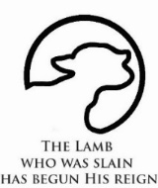
Art: Rebecca Brogan

Maranatha Mirror Messages
mmirror.net

