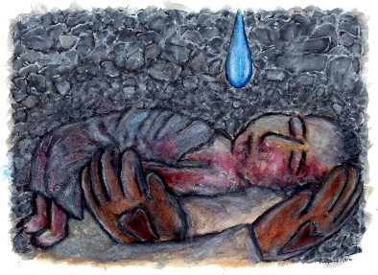

Why do innocent children die in war?
Why do evil people prosper?
Why are we waiting so long for an answer?

Even the greatest prophet of all time, John the Baptist, became impatient, when God's way of doing things didn't make sense to him.

John was sure he understood God's program when he presented Jesus to the people: "Behold the Lamb of God who takes away the sin of the world!"

But when the program didn't unfold according to John's vision,
he challenged Jesus: "Are you the One who is to come, or do we look for another?"

This side of the grave we many never know why innocent children die in war, and why evil people prosper.

But if we want to know God as the one who is Infinite Love, we need only turn our eyes to Jesus, trusting the Spirit to remove their blindness.

Wherever Jesus is,

The blind receive their sight, the lame walk, lepers are
cleansed, the deaf hear, the dead are raised up, and the
poor have good news preached to them.....even now.

Once we know him, we begin to understand that those innocent children who die in war are in his care.

And those evil men who prosper are even now under his judgment.

"Behold I am coming soon, bringing my recompense, to repay every one for what he has done. I am the Alpha and the Omega, the first and the last, the beginning and the end."
Revelation 22:12-13

Richard Bieber: 2004
Art: Ramone Romero

Maranatha Mirror Messages
mmirror.net


