If we're lucky,
we come to the point where our eyes open…

….and we see the emptiness of our frantic pursuits.

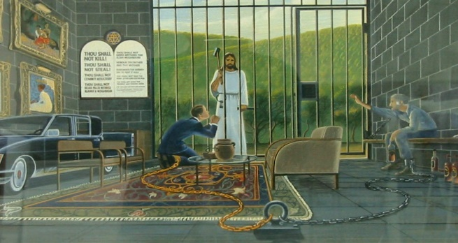
Money Fame Pleasure Power

How many years we've wasted in the chase, only to end up with an empty soul!

Our days are so few, and our momentary beauty
so swiftly fades away! Then all of a sudden we’re gone,
like grass clippings blown away in a gust of wind,
taken away to our appointment with death, leaving nothing to show that we were here. But Lord, your endless love stretches from one eternity to the other, unbroken and unrelenting toward those who fear you and those who bow face down in awe before you. Your faithfulness to keep every gracious promise you’ve made passes from parents, to children, to grandchildren, and beyond. Psalm 103:15-17

What a relief to discover the better way!

To find the path that leads beyond this world's fleeting delights...

….to God.

If you haven't found it yet, it's there for you.

All you have to do is turn from the empty chase,
lift up your heart, and ask.

Ask, and it will be given you, Seek and you will find,
Knock and it will be opened to you. Matthew 7:7

Richard Bieber: 2015
Art: courtesy of the family of Chuck Wilkinson

Maranatha Mirror Messages
mmirror.net


maranathamirror18@gmail.com


