HOW DESERTED LIES THE CITY

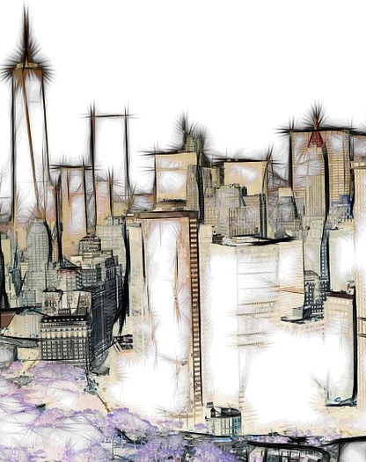

How deserted lies the city, once so full of people. (Lamentations 1:1)

These words from scripture seem to be a very accurate view of our city.

There is an emptiness ... a feeling of despair as we look across this city, or even in our own neighborhoods.

But this despair that weighs down upon this city is nothing compared to the weight of despair and sorrow and fear and guilt I'm carrying in my own heart.
The destructive path my life has taken, hurting others as well as myself, is at times more of a burden than I can carry.

"What can I do about this guilt, fear, anger?"

The first thing I must realize is that I can do nothing... because One has already taken this responsibility upon himself to rid me of my sin, my shame, my guilt....

JESUS.

Come to him ... tell him everything. He is listening and wants to unbind from your shoulders the weight you're carrying.

- His forgiveness in complete.
- His love is sure.

He will guide you from this day on if you let him. Your bitter weeping will stop and the joy of the Lord will flood your heart.

They shall hunger no more, neither thirst any more; the sun shall not strike them, nor any scorching heat. For the Lamb in the midst of the throne will be their shepherd, and he will guide them to springs of living water; and God will wipe away every tear from their eyes."
(Revelation 7:16-17)

Messages: Richard E. Bieber
Artwork: Gerd Altmann (Geralt on Pixabay)


Maranatha Mirror Messages
mmirror.net


maranathamirror18@gmail.com

