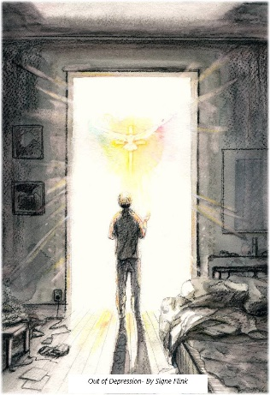
…..The unsought gift.

The gift that brings the future into focus.

The fountainhead of all true vision.

Hope greets you at the opening of the day.

Takes you by the hand.

And leads you forth with the confidence and wonder of a little child.

May the God of hope Fill you with all joy and peace in believing, So that by the power of the Holy Spirit
You may abound in hope. (Romans 15)

You do not have it in yourself. It comes from only one source:

God himself.

Ask for it.

Pursue it.

Divest yourself of everything that hinders it.

"I am the door; if anyone enters by me, he will be saved, and will go in and out and find pasture. The thief comes only to steal (hope) and kill (hope) and destroy (hope); I came that they might have life and have it more abundantly." (John 10)

Listen to him, and he will give you the gift of hope.

Walk with him, and he will sustain you in it.


Richard Bieber: 2020
Art: Signe Flink

Maranatha Mirror Messages

mmirror.net


maranathamirror18@gmail.com

