HERE COMES JESUS!

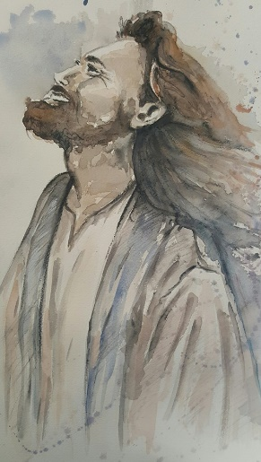
He’s not walking on the water this time.

But he will lift you up.
And he will help you to stand.
And he will make you whole.

He will confirm to you every word he has ever spoken.

He will not force his way into your heart.

He waits for you to open the door.

Cry out to him in your need.

Commit your soul and body into his care.

He will touch you afresh.

And you will know that you have been touched by him.

Creeds and doctrines are fine, but they are no substitute for a personal connection.

“.....That I may know him, and the power of his resurrection,
and may share in his sufferings...” (Philippians 3:10)

Knowing Jesus is adventure that never stops once it has begun.

But it’s up to us to keep our side of the relationship going.

“If a man loves me, he will keep my word, and my Father will love him, and we will come to him and make our home with him.” (John 14:23)



Message: Richard E. Bieber 2005
Art: Courtesy of Cindy MacDonald
Maranatha Mirror Messages
mmirror.net

maranathamirror18@gmail.com

