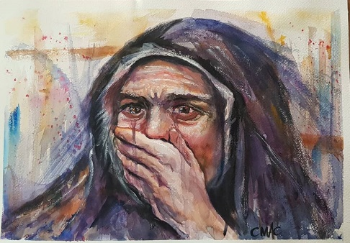
Awe.
Fear and trembling.

Sudden awareness of our own uncleanness.

Only when we come to such a state has the glory of God broken through the crust of our soul.

It happened to Job.
It happened to Isaiah.
It happened to Mary.
It happened to Peter.

…. It needs to keep happening to us.

Glib worship, Synthetic praise, is an abomination to the living God.

…. Who is Light.
…. In whom is no darkness at all.

The same arrogance and self-righteousness that blinded the Pharisees when the Son of Man walked among them has dulled our ears to the sound of his voice.

No wonder we are powerless to free the captives and restore the lost sheep!

The Master waits for us to take off our shoes in his presence, and repent of ourselves.

"I know your works; you have a name of being alive and are dead. Awake and strengthen what remains and is on the point of death, for I have not found your works perfect in the sight of my God."
Revelation 3

Message: Richard E. Bieber 2012
Artwork: Cindy MacDonald

Maranatha Mirror Messages
mmirror.net


