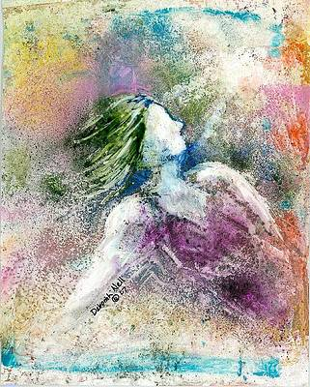

The world is awash in words.

Words that sell.
Words that threaten.
Words that seduce.
Words that deceive.

Our ears grow dull with the noise. And yet….

There are words that pierce this cacophony with power.

Words that explode in the heart and awaken it. Heal it.

“Your sins are forgiven.”
“Rise and walk!”

“Follow me.”

Words spoken by the Master of all things, directly to you.

“Rise and Walk”

Once you hear those words, you are never the same.

Whether you seize them and follow their lead, or push them aside as an annoyance, Your life is never the same.

Hearing those words, you have encountered Truth.

You have seen the Light, which will follow you all the days of your life, either as your Savior. or your Judge.

Messages: Richard E. Bieber
Art: Courtesy of Deborah Nell

Maranatha Mirror Messages

mmirror.net

