EXPECT IT

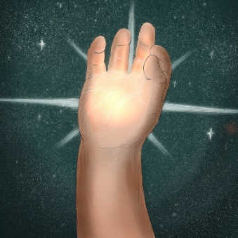

It is no accident that you find yourself reading these words.

You were drawn here to receive a promise:

The Lord Jesus, who has already taken the burden of your guilt upon himself, is addressing you in the power of his resurrection.

Calling you to follow him.

Whether for the first time in your life or for the thousandth time, he calls you by name:

"Follow me."

Moreover the Lord Jesus will confirm his call to you in an unmistakable way.

Expect it.

Expect new light for your path.

Fresh light from heaven to renew your mind.

….when you answer his call.

The true light that enlightens everyone was coming into the world. He was in the world, and the world was made through him, and the world didn’t recognize him. He came to his own, and those who were his own didn’t receive him. But as many as received him, to them he gave the right to become God’s children, to those who believe in his name: who were born not of blood, nor of the will of the flesh, nor of the will of man, but of God.
John 1:9-13

Messages: Richard E. Bieber
Artwork: Chris Powers at Full of Eyes
Maranatha Mirror Messages

mmirror.net

