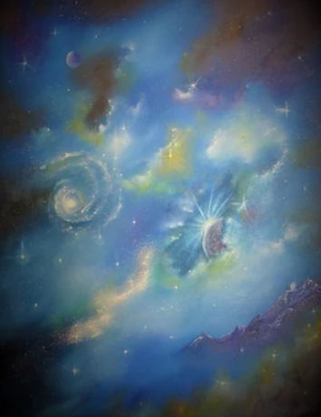
ETERNITY'S EDGE

Lord, you have always been our eternal home,
our hiding place from generation to generation.
Long before you gave birth to the earth
and before the mountains were born,
you have been from everlasting to everlasting,
the one and only true God.
Psalm 90 (TPT)

As long as we are in these bodies of flesh and blood, we are trapped in time.

And yet….

Every step we take is taken on the edge of Eternity.
Every breath we draw brings us closer to the ultimate Awakening.

Meanwhile, the Eternal Logos, who once said, 'Let there be light!" ….

Has entered our realm.
Has spoken words that impart life.
Has taken our sin-sickness down into his death,

And now, alive from the dead, invites you to enter the Eternal Realm.

Not after you die.
But at this moment.

"You are not yet fifty years old, and you have seen Abraham?" "Before Abraham was, I Am." \

Here I am, Lord!

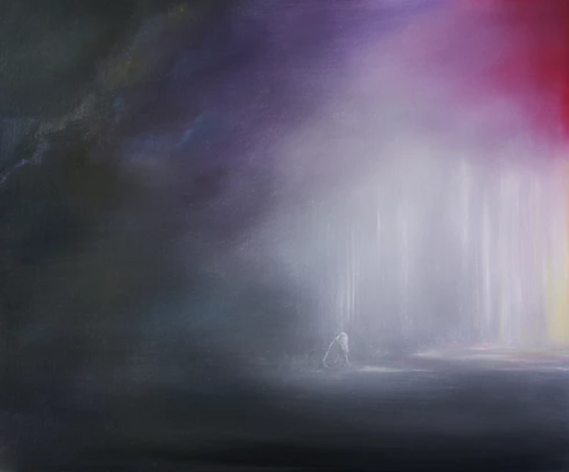

Speak, and I will listen.
Guide, and I will follow.

Prayer: Holy Lord, help us to sense that we live on the edge of eternity. Help us to know that these finite, limited lives of ours can connect now with your holy goodness, your eternal realm now if only we would stop, listen, and follow. Thank you for such a gift. Keep us from squandering it. Amen.
Maranatha Mirror

Message: Richard E. Bieber 2013
Featured Artist: Permission and kindness of Anna Sophia at etsy.com/shop/AnnaSophiasArt
Maranatha Mirror Messages
mmirror.net

