ENCOUNTERING THE HOLY

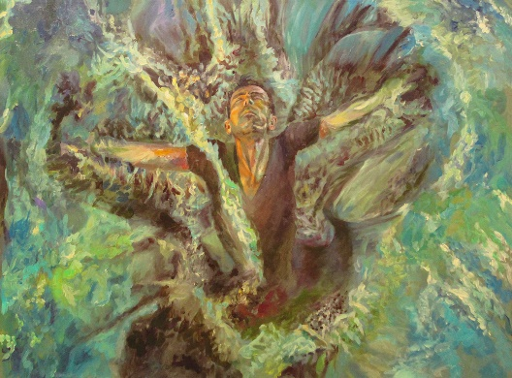

Our Father, who art in heaven, Hallowed be thy name.

The universe is ruled…
…not by a machine.
…not by a “principle.”

But by a Holy Presence, whose glory would blind our eyes.

Angels worship.
Demons tremble with fear.
But humans are unaware.

They see nothing, hear nothing, know nothing,
until they stumble into their personal burning bush.

One glimpse of his glory,
One hint of the sound of his voice,
And you are on your face.

One day soon the whole world will behold that glory,

And fall on its face.

The hills melted like wax at the presence of the Lord.
At the presence of the Lord of the whole earth.
The heavens declare his righteousness,
And all the people see his glory.
Psalm 97

But the time to take off our shoes and acknowledge his Holiness…

Is Now

Messages: Richard E. Bieber 2023
Artwork: Jonathan Allen Farrell
Maranatha Mirror Messages

mmirror.net

