EMERGING FROM OUR PRISONS
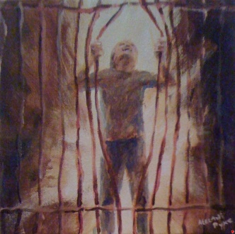

To be held in the grip of;

a resentment,
a fear,
a fantasy,
a vain dream,
… is to be spending our days in prison.
To outsiders, we appear to be free.
But deep within, we cannot seem to shake off our chains.
Everything we do is done under a cloud.

“If you continue in my word, you are truly my disciples, and you will know the truth, and the truth will make you free."

Jesus of Nazareth----John 10

His Word is the doorway to freedom.

Believing it, living it, is freedom itself.

Chains break.
Walls fall away.
All things become new…
…. for those who humble themselves and walk with the Master.
So what are you waiting for?

Messages: Richard E. Bieber 2015
Artwork: Melani Pyke
Maranatha Mirror Messages

mmirror.net

