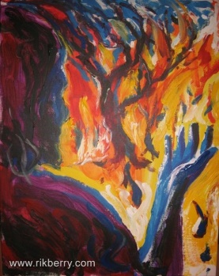

Everybody knows intuitively that God exists.

Before the mountains were born,
before you gave birth to the earth and the world,
from beginning to end, you are God.

But does God speak?

In such a way that we know that this is the voice of God?

The Jews never doubted that the Word that reached them through their prophets, was the voice of God.

calling them to repent,
giving them hope,
promising them refuge,

But who is this man who appeared in their midst, speaking words which still burn with fire?

Some say he's an Imposter.
Some say he's a madman.
Some say he's the Incarnate Word---

God speaking to humans in human language.

One thing is certain: His words still burn with fire.

When they reach you, when you are ready to pay attention, you will have to decide for yourself whether his words are the words of an Imposter, the words of a Madman, or the words of God.

And what you decide could change your life forever.



Message: Richard E. Bieber 2011
Featured Artist: Rik Berry

Maranatha Mirror Messages

mmirror.net

