THE DIVINE PULL

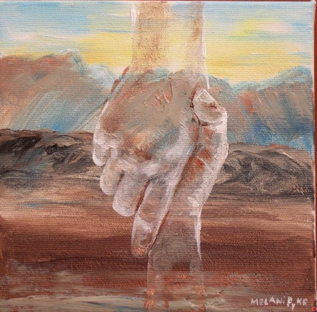

When the Spirit of God begins to pull at our souls,

we try to ignore it.

"Why should we be distracted from our own agenda?"

But the divine pull is not easily ignored.

It is relentless.

A crisis comes.

We are desperate with nowhere to turn.

We cry out for help, giving up all resistance to the divine pull.

An unseen hand reaches down and lifts us out of our pit.

At last we "get it."

We know.

The unseen God has answered our cry.

All we have to do is follow the light that illumines our path.

For it is the God who said, "Let light shine out of darkness," who has shown in our hearts to give the light of the knowledge of the glory of God in the face of Jesus Christ.
II Corinthians 4

Message: Richard E. Bieber 2011
Artwork: Melani Pyke

Maranatha Mirror Messages
mmirror.net


