DESPERATION

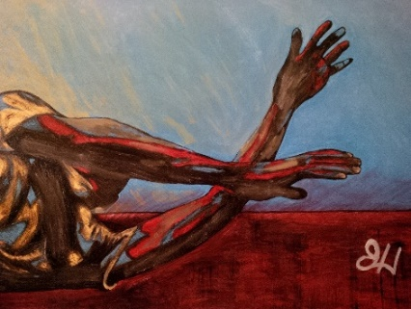

For most of us, desperation seems to be the doorway to God's World.
Until we come to the end of our resources, "God" is only a hypothesis.

As long as life is "under control" we make no serious attempt to connect with God. So God waits.

But the minute we arrive at desperation and cry, "Help me!"

A word is spoken in answer to our cry.
Things begin to change.

And at Capernaum there was an official whose son was ill. When he heard that Jesus had come from Judea to Galilee, he went and begged him to come down and heal his son, for he was at the point of death.

Jesus therefore said to him, "Unless you see signs and wonders, you will not believe." The official said to him, "Sir, come down before my child dies!"

Jesus said to him, "Go---your son will live."

The man believed the word that Jesus spoke to him and went his way. As he was going down, his servants met him and told him that his son was living. John 4:46b-51

True wisdom is to know that every moment of life is a moment of desperation. Every second is lived on the edge of the invisible Abyss.

Knowing this is true knowledge, pointing us to the One who alone can bring us into the world of faith, joy, and thanksgiving.

You will meet the living God at that point in your life where you find yourself to be the most helpless---the moment you seriously cry to him for help.

Messages: Richard E. Bieber
Artwork: Courtesy of Quinton Harris

Maranatha Mirror Messages

mmirror.net

