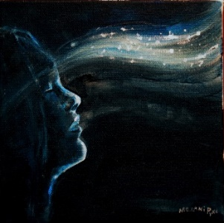

I know that death waits for me at the end of the journey.

But why think about it now?

Consider:

Today makes sense…

…if it's part of a life that keeps getting better forever.

Today is tragic….

…if it is lived on the edge of Eternal Darkness.

Do I get all the gusto I can, before I'm swallowed by Eternal Night?

Or does the light of the world beyond now guide my steps?

"Lord, if you had been here, my brother would not have died. But I know that even now, whatever you ask of God, God will give you."

"Your brother will rise again."

"I know that he will rise again in the resurrection on the last day."

"I am the resurrection and the life. He who believes in me, though he were dead, yet shall he live. And whoever lives and believes in me will never die."

Once you hear those words:

"I AM the Resurrection and the Life,"

…They await a response:

Are they the words of a madman?

Or are these the words of the Incarnate God? You decide.

And how you decide will determine the life you live ..

….between this moment and the moment of your transition to the world beyond.

Richard Bieber: 2015
Art: Melani Pyke

Maranatha Mirror Messages
mmirror.net


