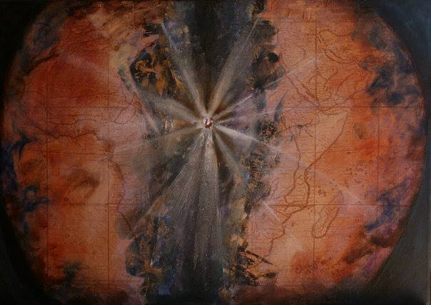

Astronomers haven't found it yet.

But a child can see it as plain as day.

When Jesus died on that cross and the earth shook and the veil in the temple was ripped apart, When, two days later the earth shook again and Jesus stepped forth from his tomb, the Firstborn of the New Creation, what was happening was that our universe was splitting its seam….

Opening a way into a new universe:

God's world, God's kingdom…

…Where the Father's will is done on earth as it is in heaven.

Anybody who wants to can step through the crack….

…. into God's world can experience God's redemptive presence, even as they walk through this troubled earth.

All you have to do is come to the place where it happened… to the cross.

"Here I am, Lord, I throw myself on your mercy!"
"Here I am, Lord, I throw myself on your mercy!"

The Lord Jesus will reach out his welcoming hand and lead you personally into God's world, and as you walk with him, your life will undergo a miraculous change.

Jesus answered, "My kingship is not of this world; if my kingship were of this world, my servants would fight, that I might not be handed over to the Jews; but my kingship is not from this world." Pilate said to him, "So you are a king?" Jesus answered, "You say that I am a king. For this I was born, and for this I have come into the world, to bear witness to the truth. Every one who is of the truth hears my voice." (John 18:36-37)

Messages: Richard E. Bieber 2003
Artwork: Kindness of Elani Lubbe (South Africa)

Maranatha Mirror Messages
mmirror.net


