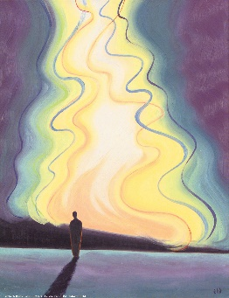

Suddenly, out of nowhere, you are arrested by the awareness that God is there.

All arguments for and against "the existence of God" fall away.

You just know that you are known by the One who rules the universe.

***Where could I go from your Spirit?  
Where could I run and hide from your face?  
If I go up to heaven, you’re there!  
If I go down to the realm of the dead, you’re there too!  
If I fly with wings into the shining dawn, you’re there!  
If I fly into the radiant sunset, you’re there waiting!   
Wherever I go, your hand will guide me; your strength will empower me.***

***Psalm 139:7-10***

"What's going on?" you say to yourself.

"Am I hallucinating? Am I losing my grip?"

No, you have begun to awaken.

You are being called to life by the Living Word.

A door has opened for you into God's world.

**The next step is yours.**

***"Truly, truly I say to you, the hour is coming, and now is, when the dead will hear the voice of the Son of God…. ….and those who listen (who respond) will live."***

***John 5:25***

*Message: Richard E. Bieber 2015*

*Artwork: Elizabeth Wang*

[**Maranatha Mirror Messages**](http://mmirror.net/more-messages/)

[mmirror.net](http://mmirror.net/)

](http://mmirror.net/about/)