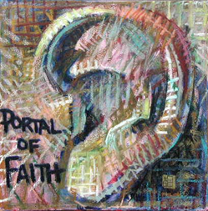

***Morning by morning he wakens,***

***He wakens my ear***

***To hear as those who are taught.***

*Isaiah 50*

The fact that your eyes are scanning these words could mean that something is also happening to your ear.

There is an ear that transcends normal hearing, that penetrates the spirit realm, and begins to hear a Word.

It hears a Word which is holy.

---inspires the removal of your shoes.

It hears a Word which is good.

---because you know it is eternally true.

It hears a Word which gives life.

---it lifts you out of yourself, quickens you.

This Word is closer to you at this moment than your own breath.

If you are willing to listen, it will awaken your ear.

All you have to do is be still---and yield the moment it reaches your heart.

***Morning by morning he wakens, he wakens my ear***

***To hear as those who are taught.***

***The Lord God has opened my ear,***

***And I was not rebellious, I turned not backward.***

***After this many of his disciples drew back and no longer went about with him. Jesus said to the twelve, "Will you also go away?" Simon Peter answered him, Lord to whom shall we go? You have the words of eternal live; and we have believed, and have come to know that you are the Holy One of God." John 6***

**"The words that I have spoken to you are Spirit and life."**

*Message: Richard E. Bieber 2008*

*Artwork: Wayne Forte*

](http://mmirror.net/about/)[**Maranatha Mirror Messages**](http://mmirror.net/more-messages/)

[mmirror.net](http://mmirror.net/)